PID Controller Tuning and Application Practice

- Based on Liquid Level Control System -

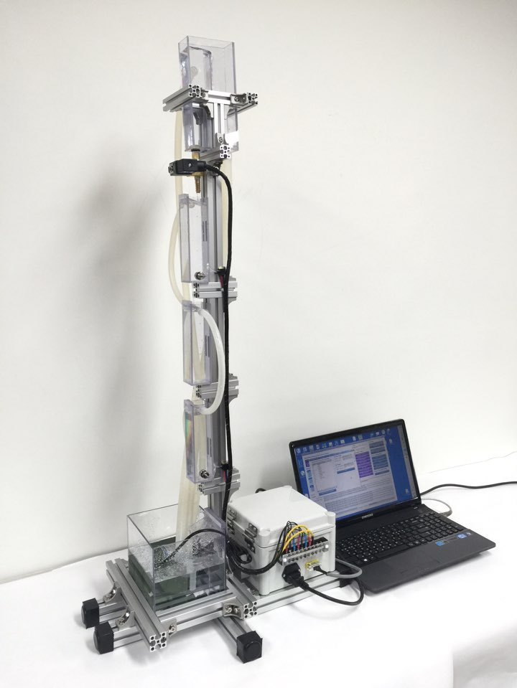

**TBB, PSE Lab.**

**Department of Chemical Engineering of Kyungpook National University**

**Tel: +82-53-950-6838, CP: +82-10-8912-6572**

**HP: www.tbb-automation.com, pse.knu.ac.kr**

**Email: suwhansung@knu.ac.kr**

**Contents**

1. **Purpose of Experiment -------------------------------------------- 1**
2. **Theory -------------------------------------------------------------- 2**
3. **Closed-loop Control System -----------------------------------2**
4. **PID Controller -------------------------------------------------- 2**
5. **Process Modeling ---------------------------------------------- 2**
6. **PID Tuning ------------------------------------------------------ 4**
7. **Experimental Equipment ------------------------------------------ 5**
8. **5 Water Tanks, Pump ------------------------------------------ 6**
9. **Data Acquisition Box ------------------------------------------ 6**
10. **Control Valve --------------------------------------------------- 6**
11. **Pressure Sensor ------------------------------------------------ 6**
12. **Procedure of Experiment ----------------------------------------- 7**
13. **Experimental Results and Discussions ---------------------------13**
14. **Further Discussions ------------------------------------------------15**

**PID Tuning and Application Practice based on the Liquid Level Control System**

1. **Purpose of Experiment**

Understanding the whole procedure of the PID tuning and application by practicing the automatic PID control of the liquid level of the 4-th tank of the below liquid level control experimental equipment.

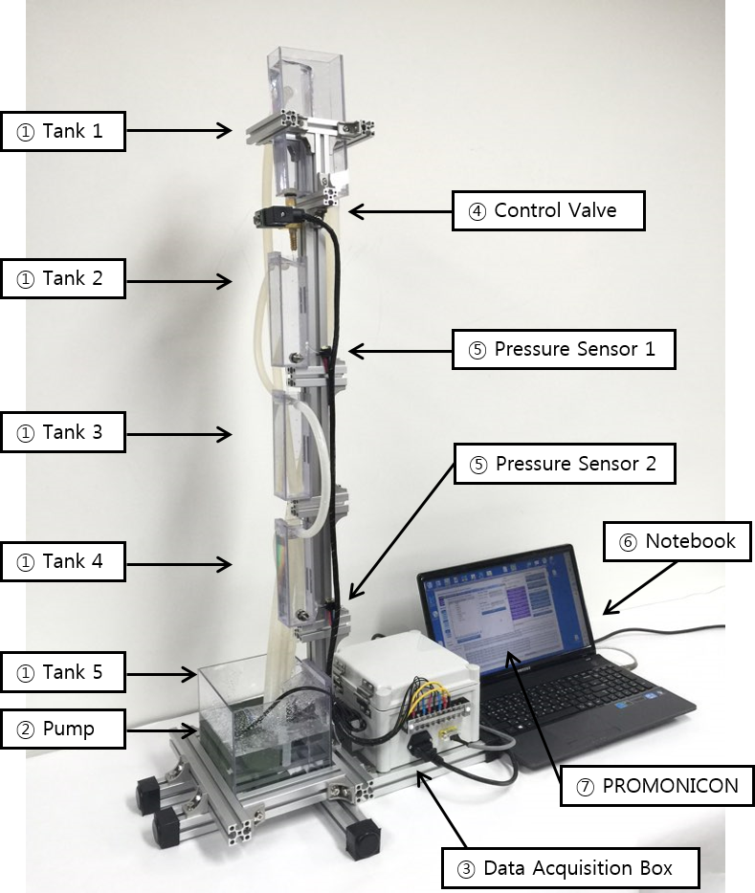

Figure 1. Experimental Equipment for Automatic Liquid Level Control

1. **Theory**
2. **Closed-loop Control System**

The PID controller () adjusts the control output () to derive the process output () to the setpoint ().  denotes the process.  is the process input, equivalently, the control output. The setpoint is a desired process output. When the process input () varies for the variation of the process output (), it is called closed-loop control system. The liquid level of the automatic liquid level control system corresponds to the process output.

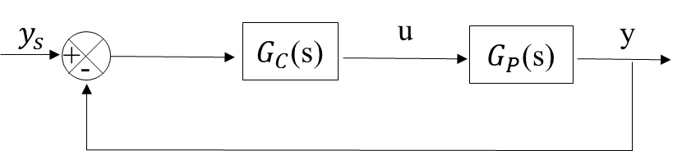

Figure 2. Closed-loop Control System

1. **PID (Proportional-Integral-Derivative) Controller**

PID Controller is composed of the following three parts.

Proportional (P) part : 

Integral (I) part : 

Derivative (D) part : 

The output of the PID controller is the linear combination of the three parts (proportional part, integral part and derivative part of the control error) as shown below.



Where ,  and  are the proportional gain, integral time, derivative time, respectively.  is time. Determining the parameters of , and  appropriately to achieve high control performance is called PID tuning.

1. **Process Modeling**

First of all, the process dynamics should be identified in the form of the model to determine , and  of the PID controller appropriately, an essential part to guarantee good control performances. Obtaining the process model in the form of a transfer function or frequency responses is called process modeling.

In this practice, we will obtain the first order plus time delay (FOPTD) model using the process reaction curve (PRC) method among various existing modeling methods. The procedure of the process reaction curve method is as follows:

**①** First, keep the process steady state. Next, enter a step-wise process input of which the magnitude is . Then, the following process reaction curve will be obtained.

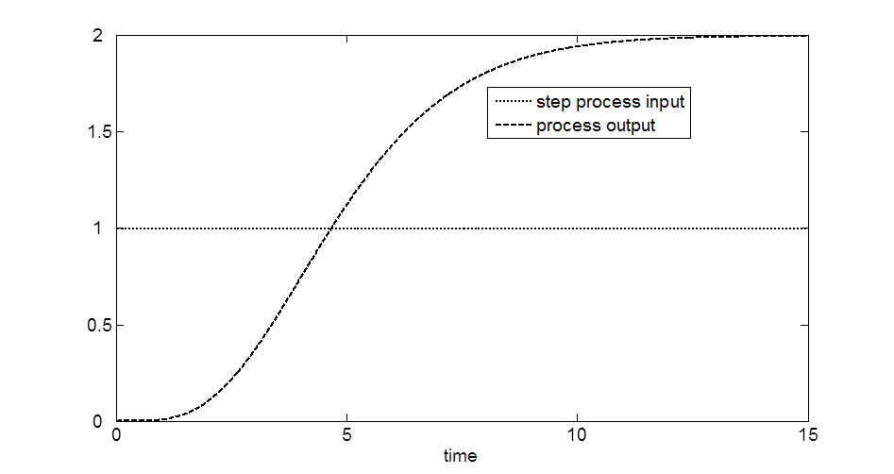

Figure 3. Process Reaction Curve Method

**②** Draw a tangent line at the inflection point of the process reaction curve as shown in Figure 4 and obtain the model parameters of ,  and  as shown in Figure 4.

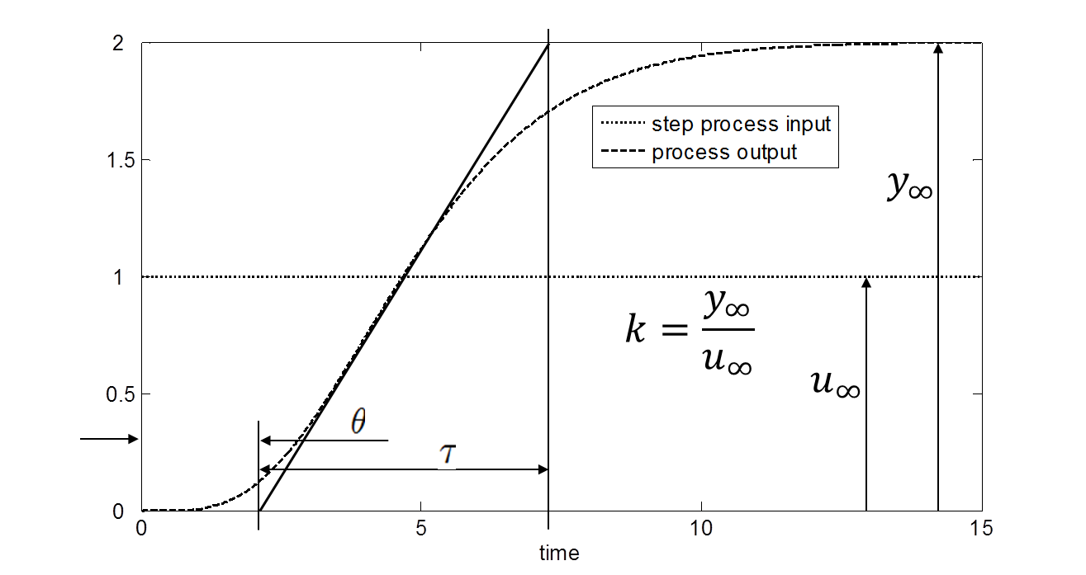

Figure 4. Estimating the model parameters of the first order plus time delay model from the process reaction method

Where, ,  and  are called gain, time constant and time delay. The physical meaning of the time constant is how fast the process responds to the process input. The time delay is the time required for the process input to affect the process output for the first time. The gain represents how much the process output changes for the variation of the process input from the steady state point of view. The transfer function corresponding to the three model parameters is . This is called the first order plus time delay model.

1. **PID Tuning**

After we obtain the process model, the tuning parameters of , ,  can be easily calculated by a PID tuning rule. In this practice, the IMC tuning rule will be used among many available tuning rules. The IMC tuning rule in Table 1 straightforwardly provides the PID tuning parameters of ,  and  for given the model parameters (,  and ). The whole tuning procedure finally finishes by confirming the tuning performance after applying the obtained tuning parameters to the PID controller.

Table 1. The IMC Tuning Rule

|  |  |  |  |
| --- | --- | --- | --- |
| Controller | Tuning Parameters | | |
| *kkc* | *τi* | *τd* |
| PI |  |  | *-* |
| PID |  |  |  |

PID Controller: , PI Controller: 

1. **Experimental Equipment**



Figure 5. Experimental Equipment for Automatic Liquid Level Control

The experimental equipment looks like Figure 5. It is composed of ① 5 water tanks ② pump ③ data acquisition box ④ control valve ⑤ pressure sensors ⑥ notebook ⑦ PROMONICON software.

1. **5 Water Tank, Pump**

Water tank 1 is to provide a constant pressure head to the automatic valve. Water tank 2, water tank 3, water thank 4 are to realize the third order process dynamics. Water tank 2 and water tank 4 have pressure sensors to measure the liquid level. Water tank 5 has a pump to circulate the water up to the water tank 1.

1. **PROMONICON**

It is an automation software to realize the PID control algorithm. The process variables such as liquid levels and valve opening can be measured and adjusted through the automation software.

1. **Data Acquisition Box**

Data Acquisition Box is to convert the electrical signal from the pressure sensor to the digital signal and send them to PROMONICON in the notebook. Also, it is to convert the digital signal from PROMONICON in the notebook to an electrical signal to adjust the opening of the automatic valve.

**4) Control Valve**

Control valve adjusts the valve opening in proportional to the electrical voltage set by the data acquisition box according to the digital signal of PROMONICON.

**5) Pressure Sensor**

The measurement range of the pressure sensor is 0~400mm H2O. It outputs 4~20mA in proportional to 0~400mm H2O.

1. **Procedure of Experiment**
2. The data acquisition box and the serial port of the serial-USB converter should be connected before starting the experiment. Also, the automatic valve and pressure sensors should be connected to the data acquisition box as shown in Figure 5.
3. Run PROMONICON-Bridge. And, click Program Start button and Scan Data button as shown in Figure 6.

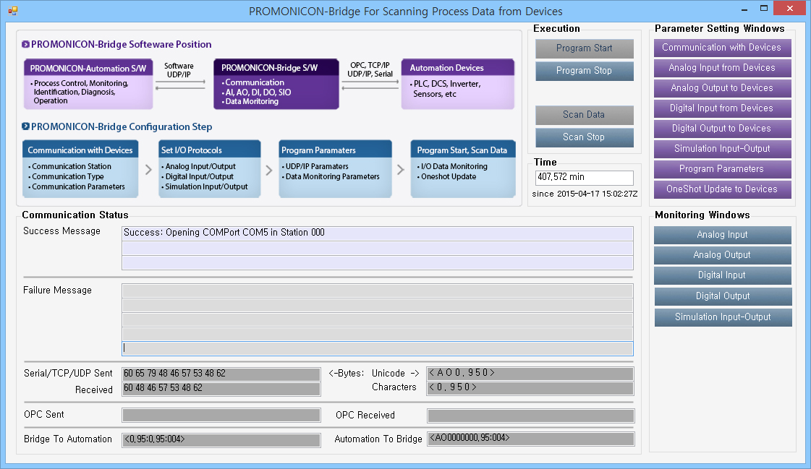

Figure 6. Main Window of PROMONICON-Bridge

1. Run PROMONICON-Automation and click Program Start button and Scan Data button as shown in Figure 7.

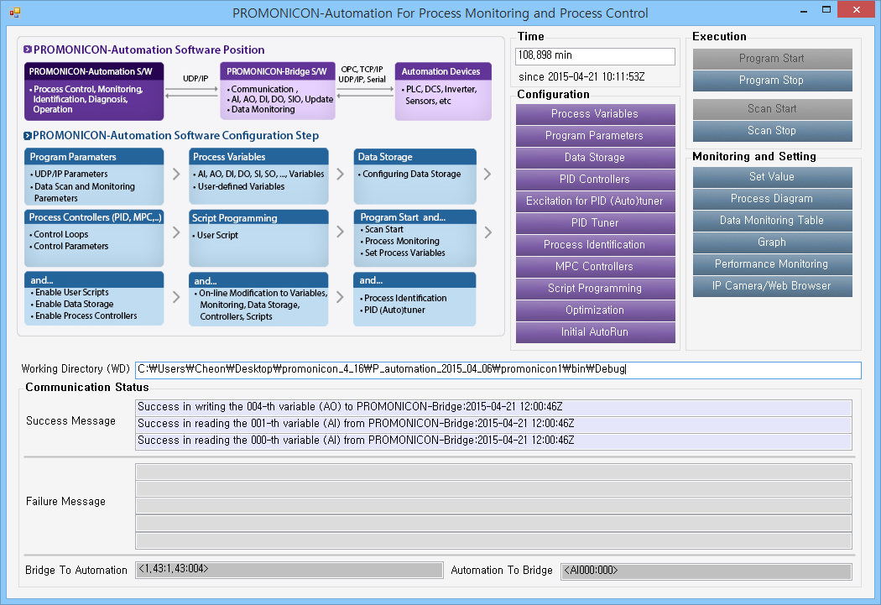

Figure 7. Main Window of PROMONICON-Automation

1. Check if the process variables are set like Figure 8 by clicking Process Variables button in the main window of PROMONICON-Automation.

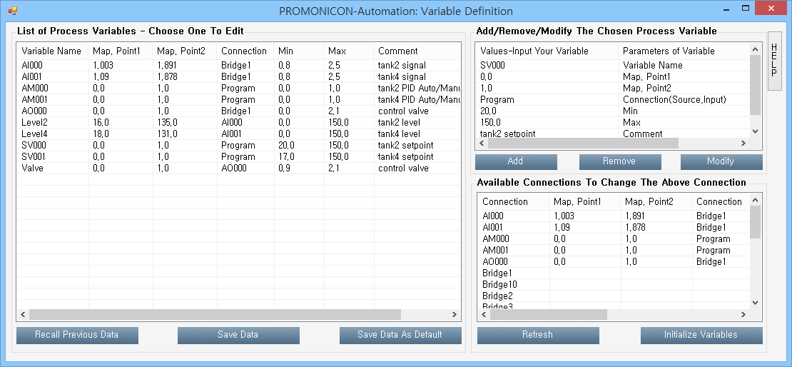

Figure 8. PROMONICON-Automation : Variable Definition

1. Click PID Controllers button in the main window of PROMONICON-Automation and check if the PID controllers are like Figure 9. Click Enable PID Control button. Here, two the PID controllers are set as shown in Figure 10. The 0-th PID controller is to control the liquid level of the water tank 2 by adjusting the opening of the automatic valve to mitigate the hysteresis effect of the automatic valve and enhance the consistency of the process dynamics. The 1-th PID controller is to control the liquid level of the water tank 4 by adjusting the setpoint of the 0-th PID controller. The 0-th PID controller and the 1-th PID controller are called the secondary controller and the primary controller. The overall control scheme is called cascade control. **The purpose of this practice is to determine the tuning parameters of the 1-th (primary) PID controller. The process output of the 1-th (primary) PID controller is the liquid level of the water tank 4 and the control output of the 1-th (primary) PID controller is the setpoint of the 0-th (secondary) PID controller.**

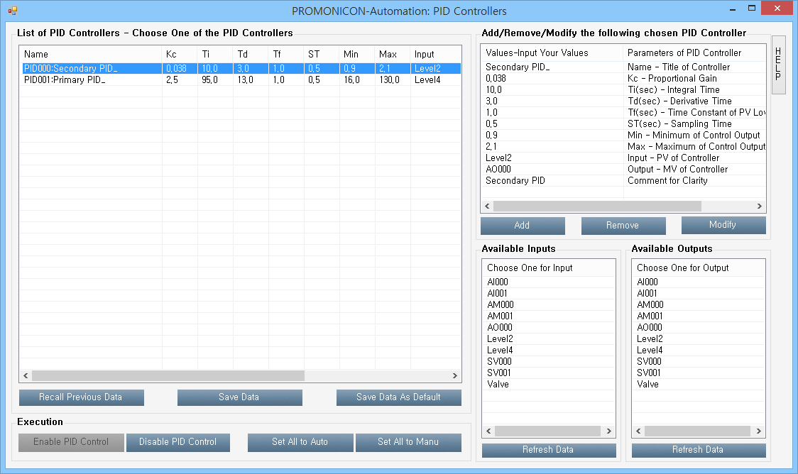

Figure 9. PROMONICAON-Automation : PID Controllers

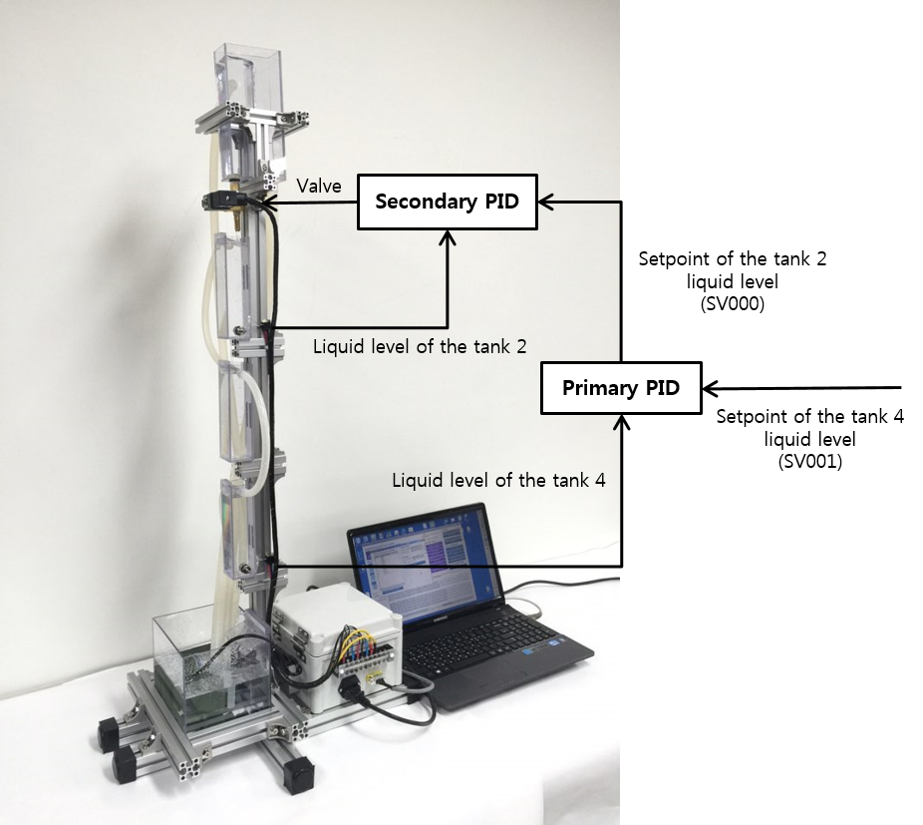

Figure 10. Cascade Control Scheme

1. Click Set Value button in the main window of PROMONICON-Automation. Then, the process variables shown in Figure 8 will be shown as in Figure 11.

**①** Set AM000 from 0 to 1 to change the manual mode of the 0-th (secondary) PID controller to the auto mode.

**②** Set SV000 to 60 and click Set button. And, wait about 5 minutes until the process becomes steady state.

**③** Click Graph button in the main window of PROMONICON-Automation and click the Update Graph button of the graph window to confirm if the process becomes steady state. When the process is steady state, set SV000 from 60 to 80 (corresponding to the step input change of which magnitude is 20). And, wait about 5 minutes again until the process becomes steady state. Then, you will obtain the process reaction curve like Figure 12.

**④** Capture the process reaction curve in the graph window and paste it to PowerPoint. And, obtain the first order plus time delay model as explained in Figure 4.

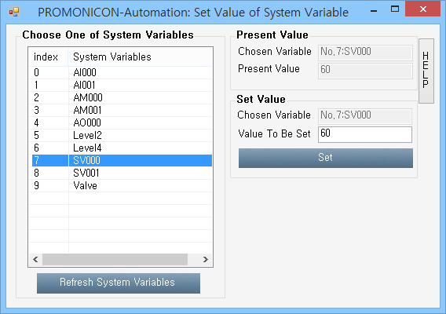

Figure 11. PROMONICON-Automation : Set Value

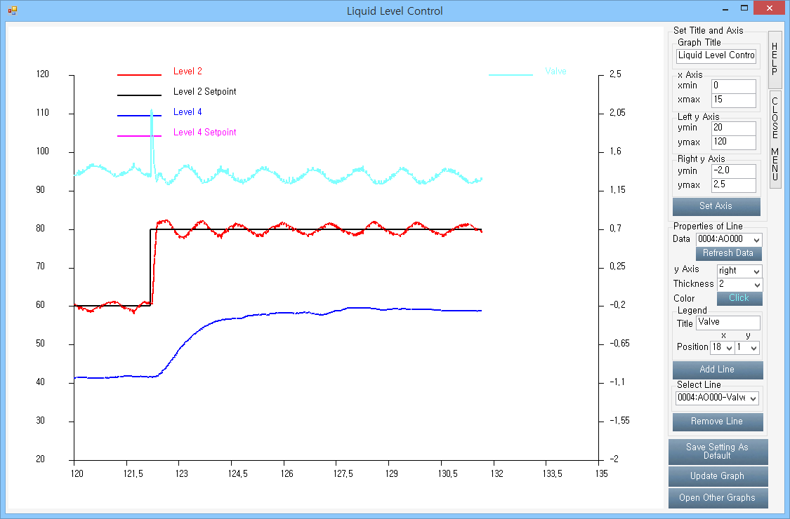

Figure 12. PROMONICON-Automation : Graph

1. Calculate the 1-th PID tuning parameters using the IMC tuning rule of Table 1 for the obtained first order plus time delay model parameters. Enter the calculated tuning parameters of the 1-th (primary) PID controller (,  and ) to Kc, Ti and Td values of PROMONICON-Automation : PID Controllers window and click Modify button as shown in Figure 13.

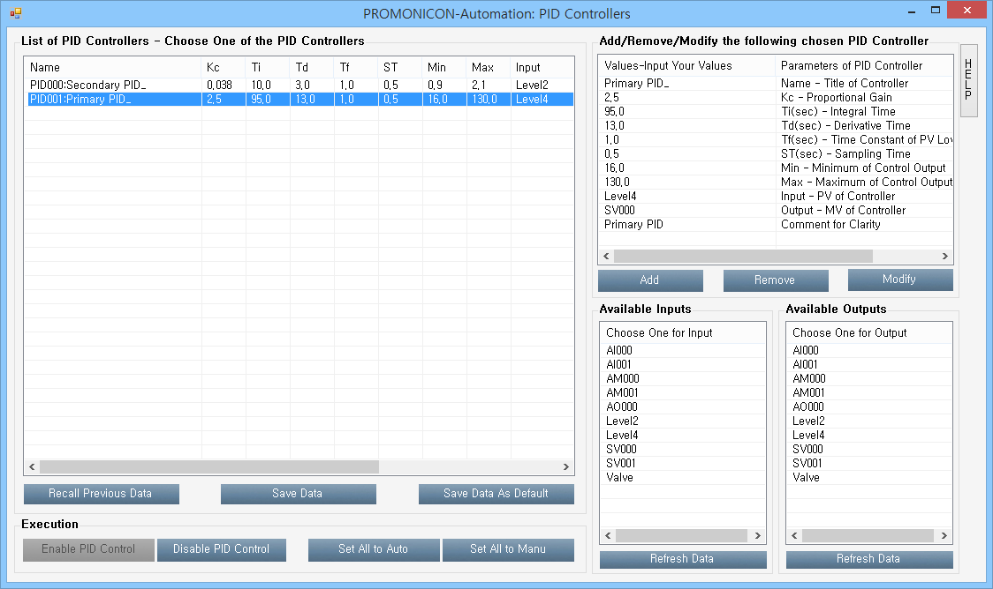

Figure 13. PROMONICON-Automation : PID Controllers

1. Set SV001 (setpoint of the 1-th (primary) PID controller, desired liquid level of the water tank 4) to a desired value (for example, 80). And, set AM001 from 0 to 1 to change the manual mode of the 1-th PID controller to the auto mode. Confirm if the liquid level of the water tank 4 converges to the setpoint as shown in Figure 14.

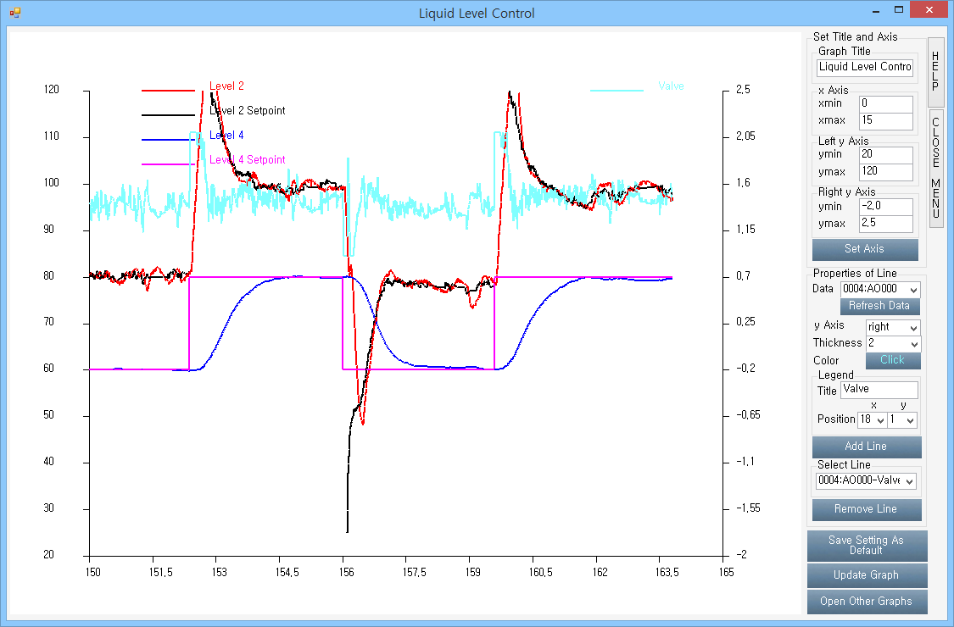

Figure 14. PROMONICON-Automation : Graph

1. **Experimental Results and Discussions**
2. Summarize the procedure to obtain the process reaction curve.

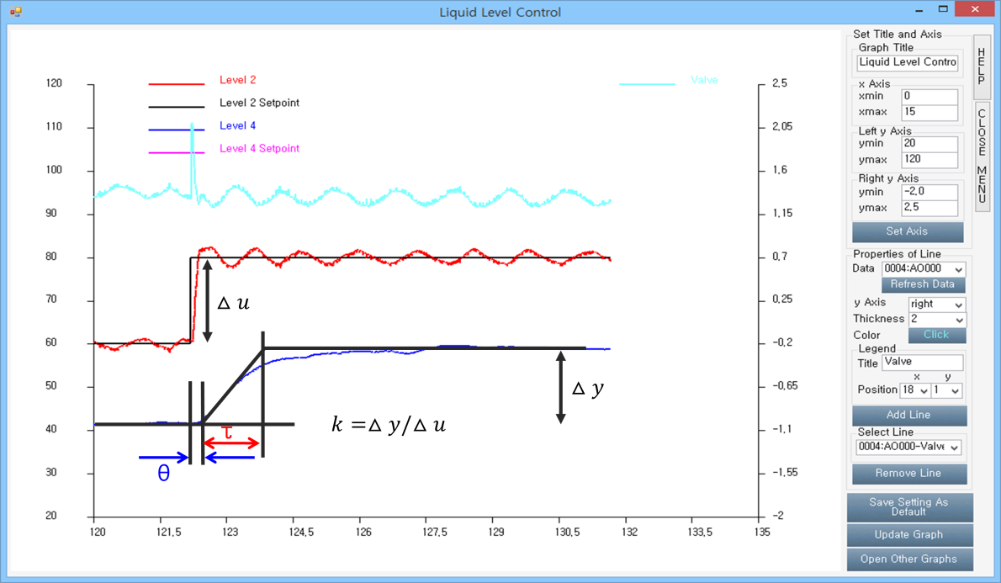

Figure 15. Process Reaction Curve Method Example

1. Summarize the procedure to obtain the first order plus time delay model from the process reaction curve.

First Order Plus Time Delay Model Example: 

1. Summarize the procedure to obtain the PID tuning parameters using the IMC tuning rule.

IMC Tuning Example - PI Controller : , , 

- PID Controller : , , 

1. Summarize the procedure to confirm the control performance by applying the tuning parameters and setpoint changes.



Figure 16. Confirming Control Performance Example

1. **Further Discussions**
2. Predict and confirm the prediction with experiments what the responses of the process would be if one of the tuning parameters increased or decreased.
3. Survey the PID tuning methods more. Choose one of them and confirm if the control performance is acceptable.

**MEMO**